1)

τcustomername asc (πcustomername (σ (customers.state = null

∧ customers.country ≠ Offices.country) ∨ (customers.state ≠ null ∧ customers.state ≠ Offices.state)

((customers) ⨝ Employees.employeeNumber = customers.salesRepEmployeeNumber

(Employees) ⨝ Employees.officeCode = Offices.officeCode (Offices))))

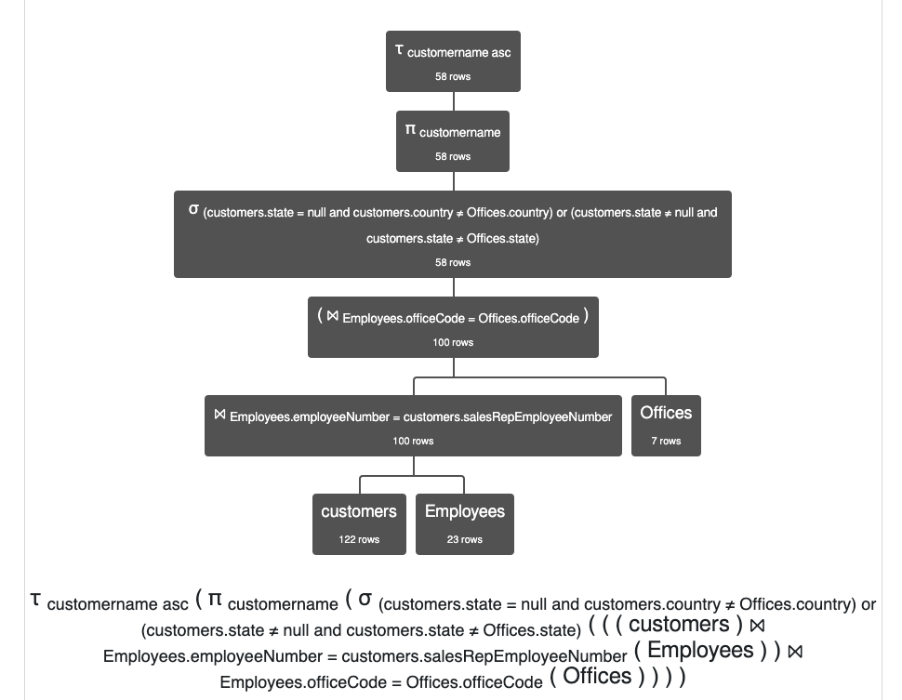

2)

τcustomername asc (πcustomername (σ (products.productName = 'Pont Yacht')

((customers) ⨝ orders.customerNumber = customers.customerNumber

(orders) ⨝ orders.orderNumber = OrderDetails.orderNumber (OrderDetails) ⨝ OrderDetails.productCode = products.productCode (products))))

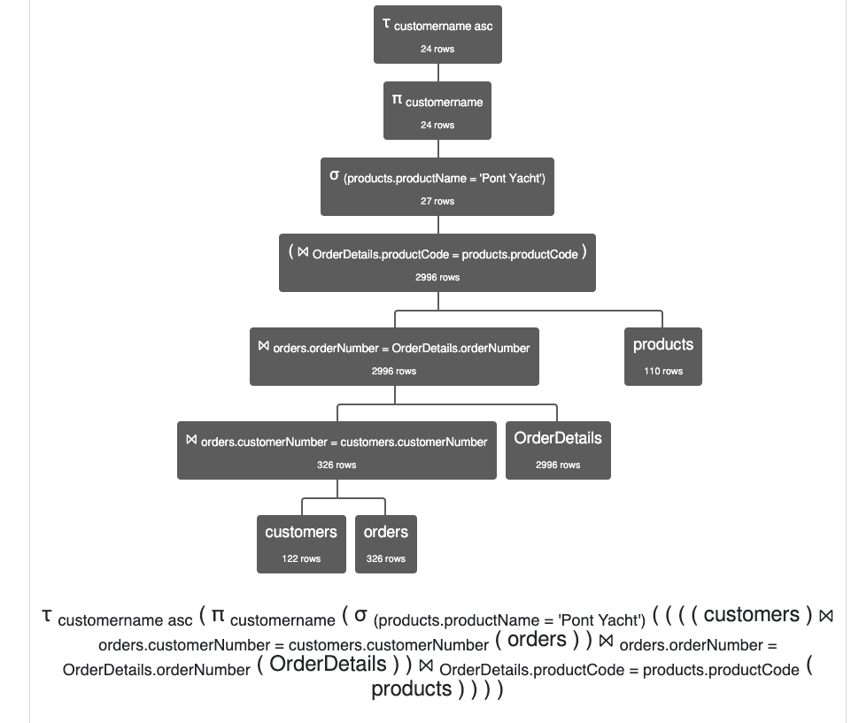

3) τOffices.officeCode (πOffices.officeCode,Offices.city,Offices.state,Offices.country (σ (products.productName = '1928 Mercedes-Benz SSK')

((Offices) ⨝ Offices.officeCode = Employees.officeCode

(Employees) ⨝ Employees.employeeNumber = customers.salesRepEmployeeNumber (customers) ⨝ customers.customerNumber = orders.customerNumber (orders) ⨝ orders.orderNumber = OrderDetails.orderNumber (OrderDetails) ⨝ OrderDetails.productCode = products.productCode (products))))

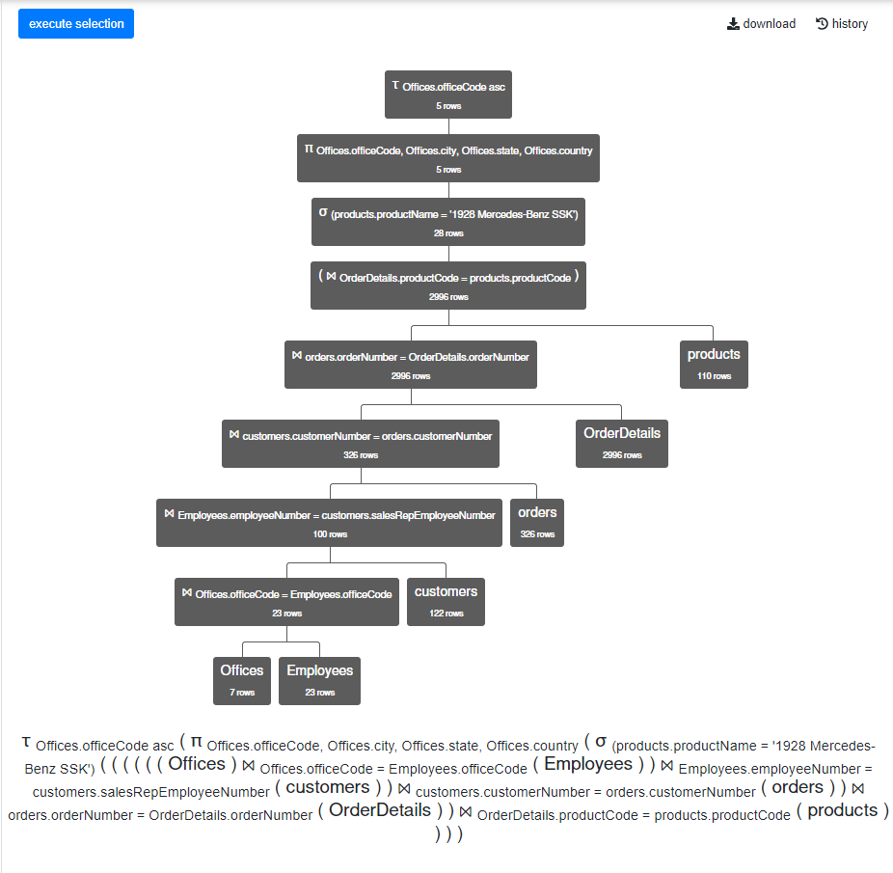

4)

τcustomers.customername, orders.orderDate (πcustomers.customername,orders.orderDate,orders.ShippedDate,OrderDetails.quantityOrdered,products.productLine,products.productName (σ ((orders.orderDate ≤date('2013-05-31') ∧ orders.orderDate ≥date('2013-05-01')) ∧ (orders.ShippedDate >date('2013-05-31') ∨ orders.ShippedDate <date('2013-05-01')))

((customers) ⨝ customers.customerNumber = orders.customerNumber (orders) ⨝ orders.orderNumber = OrderDetails.orderNumber (OrderDetails) ⨝ OrderDetails.productCode = products.productCode (products))))

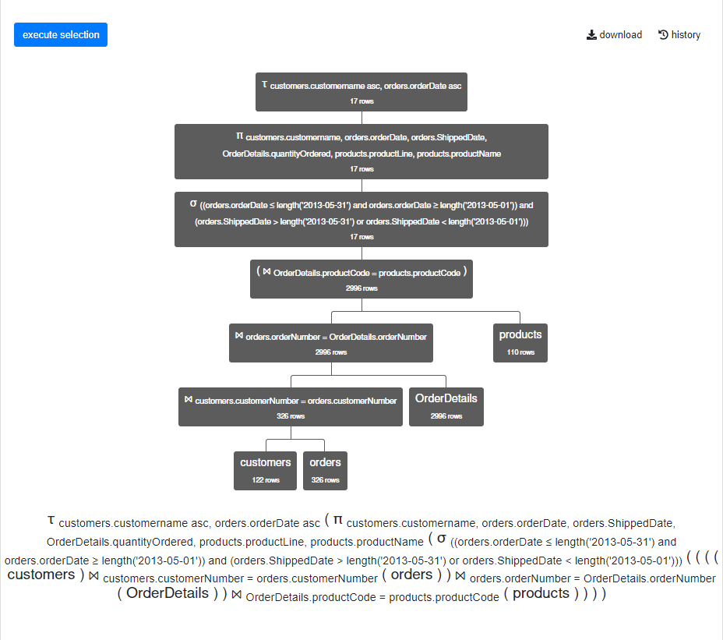

5) τcustomers.customername, orders.orderNumber (πcustomers.customername,orders.orderNumber, orders.orderDate, orders.status (σ OrderDetails.quantityOrdered > products.quantityInStock ((customers) ⨝ customers.customerNumber = orders.customerNumber (orders) ⨝ orders.orderNumber = OrderDetails.orderNumber (OrderDetails) ⨝ OrderDetails.productCode = products.productCode (products))))

